Include complex sentences, at least 5 sentences.
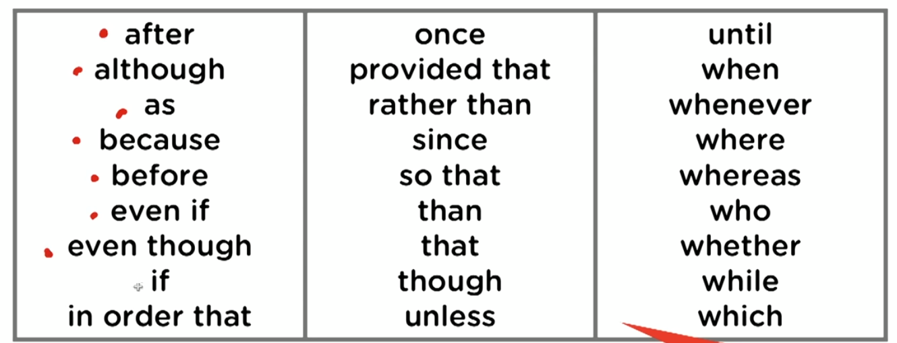
Use the above phrases for complex sentences for merging two or more ideas.
Make longer sentences with them.
Use passive, questions and compound sentences.
One question sentence at least.
Use conditional sentences, these are sentences that start with if.

Task 1:
Paragraph 1: Graph description (rephrasing the graph details in question)
Paragraph 2: Overview (no numbers!)
Paragraph 3: Key feature 1 described with numbers
Paragraph 4: Key feature 2 described with numbers
Conclusion is not needed
Don’t repeat words, use synonyms.

That is used with specific thing, which is used with non-specific things

Different people can have different opinions in all matters, same is the case with the argument of experimentation on animals. Experimentation on animals have been a practice since many years especially in the field of medical analysis, prevention and cure. Other than that, animals also have been used to track the evolution of species and their origin.

However, these experiments are very physically demanding and can cause the animal under test to undergo many biological modifications that can result in its death. For example, mice have been used since decades to test different vaccines before they can be rolled out to humans. Due to such tests, many mice die every year in search for different vaccines, and the worst part is that these deaths are usually caused by diseases which were embedded in them by scientists in bid for a cure. Similarly, in the case of farm animals especially cows and goats, these innocent animals are injected with different chemicals in hope for higher output in terms of milk or meat. Sometimes, these injections make the animal suffer from diseases that weakens them and can cause death.

Despite having all these demerits, the importance of these experiments can not be sidelined because they are very important for researchs and other benefits to the humans. Without using these animals for scientific tests, potential vaccines and medicines cannot be tested before making them available to public which can negatively affect their user's health. If the production of necessary domestic commodities is not increased especially which are gained from animals, like milk or meat, then problems can arise in their supply to the rising global population particularly in the East.

So, rather than halting the use of these animals for important scientific development and discoveries, I think it will be better to instead regulate these experiments to control the unnecessary deaths of animals and allow the scientists to continue their work for healthier and better human lives.

